**PERMATA AGRINDO**

**Company Profile**

Permata Agrindo is engaged in general supplier, general trading ,and distributor as well as cultivation in agriculture. We partner with Indonesian farmers to produce the highest quality products. We can be sure that our products are of superior quality.

**Vision**

become the best exporter in the world and promote Indonesian agriculture.

**Mission**

• Helping Indonesian farmers to become innovative farmers.

• Strategies for innovation in-stock availability and producing the best quality products from Indonesian farmers.

• Build strategic business partners with buyers, farmers, and the government in the long term.

**Value**

**Quality:** each product we sell always uses the best raw material and tested with a highly advanced machine, and certified laboratory to produce the best quality.

**Innovation**: we always innovation in developing and making new breakthroughs in producing products that have always been of market interest and strengthen the customer’s taste.

**Commitment**: commitment is one of the keys to customer trust so it is something we always take care of and cannot be ignored. All forms of privileges that we give to serve customers are things that we always take care of.

**Integrity**: integrity means telling the truth, keeping our word and treating others with fairness and respect. Integrity is one of our most cherished assets. It must not be compromised.

**PAYMENT TERM**

**We Do:**

* Accept T/T in advance or 100% payment
* 100% L/C irrevocable at sight

**WE DON’T:**

* Don’t accept DDP, USANCE LC, REVOCABLE LC

**Shipping Incoterms:**

**FOB CIF Domestic**

**Free On Board Cost Insurance Freight Shipping**

**Contact :**

* **Email:** [**PermataAgrindo@gmail.com**](mailto:PermataAgrindo@gmail.com)
* **Wa: +6283-852-153-846**
* **Website: www.**
* **FB : Permata Agrindo**

**PRODUCT**

**COFFEE**

**Coffee Process**

**ARABICA**

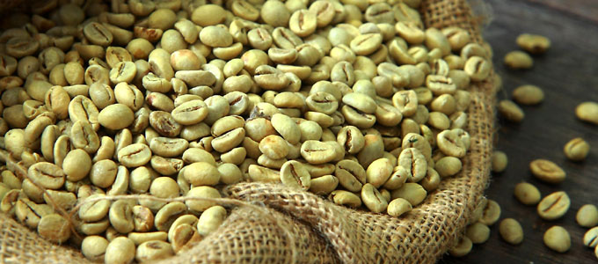

* Semi wash
* Full wash
* Wine
* Natural
* Grade (1,2,3)

**ROBUSTA**

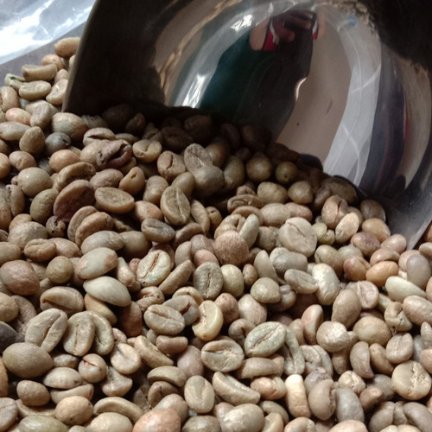

* Semi wash
* Full wash
* Natural
* Grade (1,2,3)

**LEVEL OF ROASTING**

* Light
* Medium
* Medium dark
* Dark & Beyond

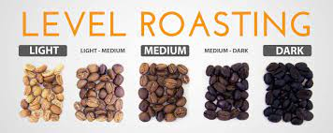

**ARABICA**

1. **Arabica Sumatra Mandheling**

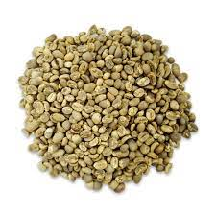

The description:

Produced from 100% pure Arabica coffee from the Madaling highlands, North Sumatra, Indonesia. Arabica Mandeling has a distinctive taste, which is a little spicy and spicy. Arabica Mandheling is not only enjoyed by local coffee lovers but has also penetrated the international market.

Specification:

• Altitude : 1,500-1,800 M.asl

• moisture : 10-12%

• grade: specialty, grade1, grade 2

• defect: depends on the grade level

• beans: green beans, roast beans, powder

• Acidity: medium

• Taste :

* Spicy herbs
* Slightly Mouthfeel

1. **Arabica West Java**

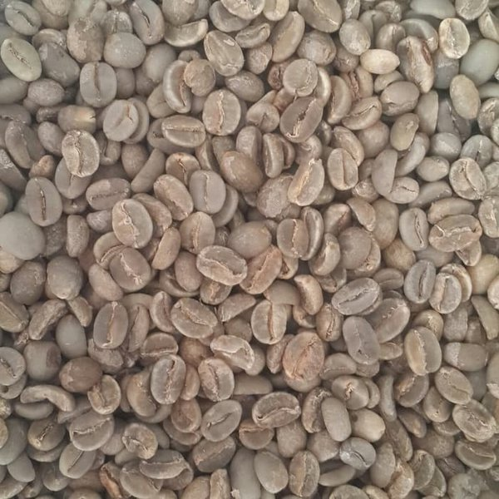

The description :

Produced from 100% pure Arabica coffee from Mount Puntang, West Java. , Indonesia. Arabica Puntang coffee was the winner of the taste category at the Specialty Coffee Association Of America Expo in Atlanta, United States, April 14-17, 2016. Until now Arabica Puntang coffee is still widely known and has loyal fans.

Specification:

* Altitude : 1,500 masl
  + Moisture:10 - 12%
  + grade: specialty, grade1, grade 2
  + defect: depends on the grade level
  + beans: green beans, roast beans, powder
  + Acidity: high
  + Taste :
* sweet
* Caramel

1. **Arabica Bali Kintamani**

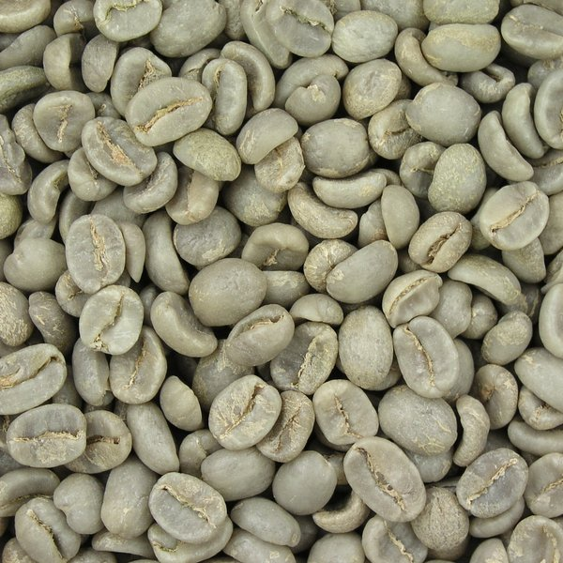

The description :

Produced from 100% pure Arabica coffee beans from Mount Batur Kintamani, Bali, Indonesia. Arabica Kintamani coffee is grown with a cider system using a traditional water system and geographical conditions that can create Arabica Kintamani coffee beans with a unique taste.

Specifications:

* + Altitude : 900 masl
  + Moisture : 12-14%
  + grade: specialty, grade1, grade 2
  + defect: depends on the grade level
  + beans: green beans, roast beans, powder
  + Acidity: medium
  + Taste :
* Fruits
* Soft Flavor

1. **Arabica Gayo**

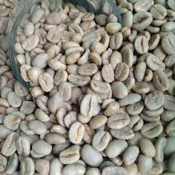

The description :

Produced from 100% pure Arabica coffee beans from the Gayo highlands, Central Aceh, Indonesia. Arabica Gayo coffee received Fair Trade Certified, from the International Trade Organization, 27 May 2010. And again obtained the highest cupping score, 10 October 2010. These certifications and achievements have further established Arabica Gayo coffee's position as the world's best organic coffee.

Specifications:

* Altitude : 1000 – 1,700 masl
* Moisture: 11 - 15 %
* grade: specialty, grade1, grade 2
* defect: depends on the grade level
* beans: green beans, roast beans, powder
* Acidity: low
* taste :
* Heavy taste
* Strong Flavor
* Not to bitter

1. **Arabica Toraja**

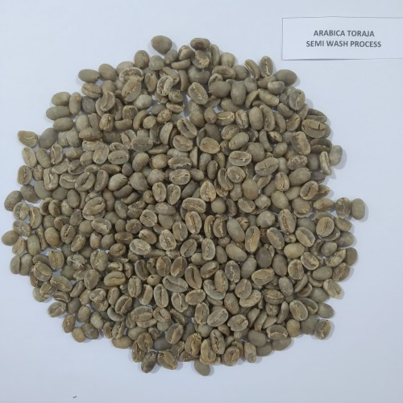

The description :

Produced from 100% pure Arabica coffee beans from the Sasean mountains, Toraja, South Sulawesi, Indonesia. Arabica Toraja coffee is one of the popular variants that has the best quality in Indonesia. With the Latin name Celeber Kalosi, Arabica Toraja Coffee has been known by coffee lovers around the world for its unique and distinctive taste.

Specifications:

* Altitude: 1,400 – 2,100 masl
* Moisture: 12 - 15%
* Grade: specialty, grade1, grade 2
* Defect: depends on the grade level
* Beans: green beans, roast beans, powder
* Acidity: low
* Taste :
* Fruity
* Spices
* Not to bitter

1. **Arabica Flores**

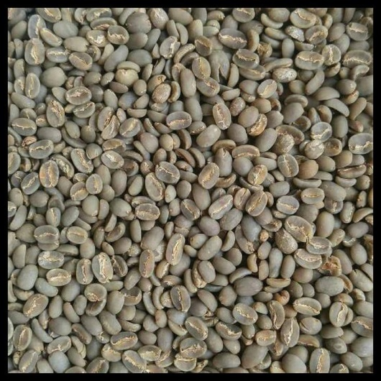

The description :

Produced from 100% pure Arabica coffee beans from the Ngada highlands, Flores, East Nusa Tenggara (NTT), Indonesia. Arabica Flores coffee is the largest export contributor for Indonesia. No wonder this coffee has become a popular coffee in the world. Arabica Flores coffee is cultivated using organic methods. Where the fertilizer used is natural fertilizer without using pesticides. This produces coffee beans with a very unique aroma and taste.

Specification:

* Altitude: 1000 – 1,500 masl
* Moisture: 12 – 15%
* Grade: specialty, grade1, grade 2
* Defect: depends on the grade level
* Beans: green beans, roast beans, powder
* Acidity: medium
* Taste:
* Caramel
* Helzanut
* Nacamid Nuts
* Strong flavor and scent

1. **Arabica Wamena**

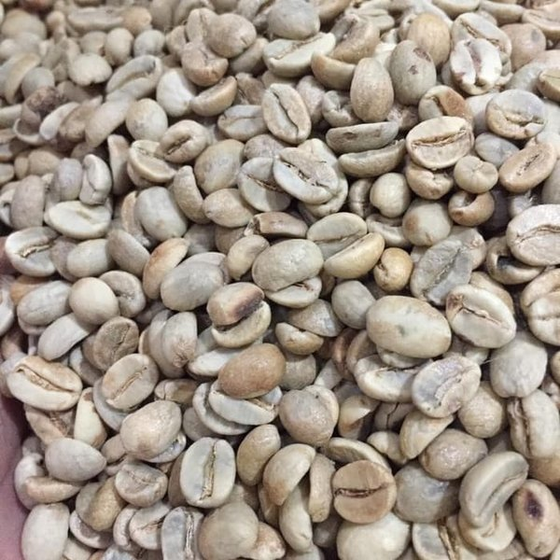

The description :

Produced from 100% pure Arabica coffee beans from the Baliem Valley, Wamena, Papua, Indonesia. Arabica Wamena coffee has a very unique taste compared to other Arabica coffees because Indonesian coffee rarely has a floral sensation. The appearance of the aroma is influenced by planting conditions that do not use pesticides and other chemical compounds.

Specification:

* Altitude: 1,200 – 1,600 masl
* Moisture: 15%
* Grade: specialty, grade1, grade 2
* Defect: depends on the grade level
* Beans: green beans, roast beans, powder
* Acidity: low
* Taste:
* Medium sweetness
* Earthy flavor
* Sweet corn

1. **Arabica Ijen Raung**

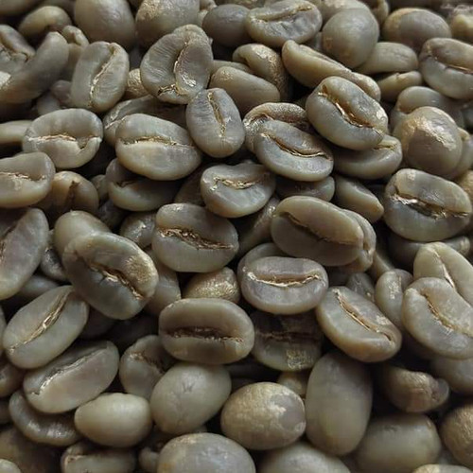

Description:

Produced from 100% pure robusta coffee beans from the foot of Mount Ijen, Bondowoso, East Java, Indonesia. Arabica Ijne Raung coffee has a distinctive taste, which is a combination of tamarind and spicy. Because of this interesting taste, it gets a certificate of geographical indication. Not only loved by local coffee connoisseurs but has been known all over the world.

Specification:

* Altitude:1,400 – 1,800 masl
* Moisture: 12-15%
* Grade: specialty, grade1, grade 2
* Defect: depends on the grade level
* Beans: green beans, roast beans, powder
* Acidity: low
* Taste:
* Sweet and juicy
* Ginger
* Tamarind

**ROBUSTA**

1. **Robusta Lampung**

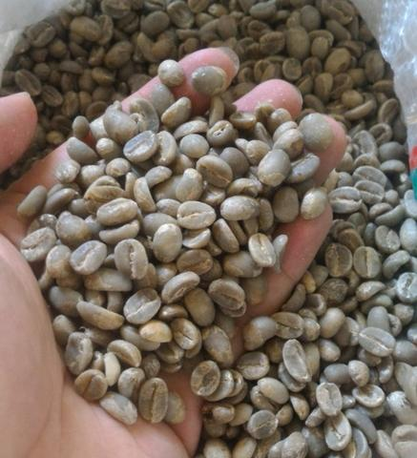

The description:

Produced from 100% pure Robusta coffee beans from plantations in Lampung, Sumatra, Indonesia. Robusta Lampung Coffee is one of the coffees that is the prima donna of coffee connoisseurs. Climate, geographical location, and fertile soil conditions affect the taste of Robusta Lampung coffee.

Specification:

* Altitude: 800 – 1,300 masl
* Moisture: 11 – 15%
* Grade: specialty, grade1, grade 2
* Defect: depends on the grade level
* Beans: green beans, roast beans, powder
* Acidity: medium
* Taste:
* high flavor
* the scent of spices & chocolate

1. **Robuta Temanggung**

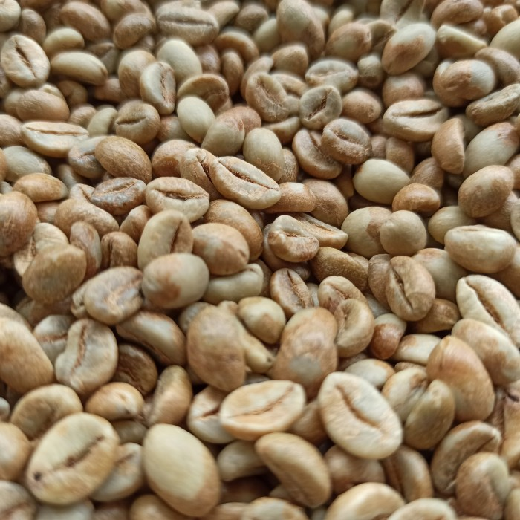

Descripsi:

Dihasilkan dari 100% biji kopi robusta murni dari perkebunan Temanggung, Jawa Tengah, Indonesia. Rasa kopi Temanggung yang sangat kuat menjadi favorit dan memiliki harga jual yang tinggi di Negara – Negara Eropa dan Timur Tengah. Bahkan, kopi robusta Temanggung dianggap segabagai minuman mewah.

Spesifikasi:

* Ketinggian: 400 – 800 Masl
* Moisture : 12 – 15 %
* grade: specialty, grade1, grade 2
* defect: depends on the grade level
* bean: greenbean, roast bean, powder
* Keasaman: low
* Taste:
* Bold Flavour
* Coklat

1. **Robusta Dampit**

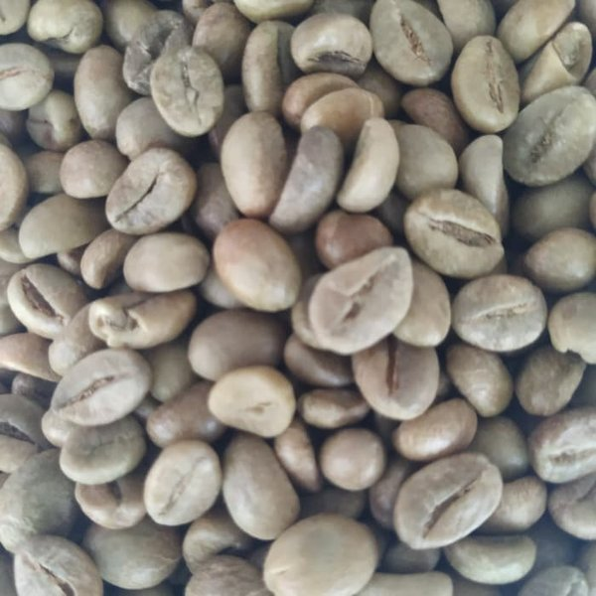

The description:

Produced from 100% pure robusta coffee beans from the foot of Mount Semeru, Dampit, Malang, Indonesia. Robusta Dampit has a chocolaty color taste combined with a strong body of coffee making it one of the best coffees in Indonesia.

Specification:

* Altitude: 700-800 masl
* Moisture: 11-13%
* Grade: specialty, grade1, grade 2
* Defect: depends on the grade level
* Beans: green beans, roast beans, powder
* Acidity: low
* Taste:
* Nutty
* Chocolate
* Bold Flavor

1. **Robusta Ijen Raung**

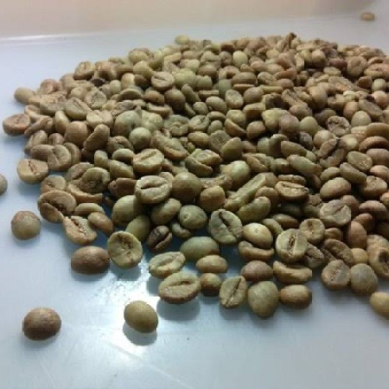

The description:

Produced from 100% pure robusta coffee beans from the foot of Mount Ijen, Bondowoso, East Java, Indonesia. Robusta Ijen Raung has a fairly distinctive taste. In addition to a bitter taste, this coffee also has a sour and sweet taste like chocolate.

Specification:

* Altitude:1,400 – 1,800 masl
* Humidity: 12-15%
* Grade: specialty, grade1, grade 2
* Defect: depends on the grade level
* Beans: green beans, roast beans, powder
* Acidity: medium
* Tastes:
* earthy fresh nutty
* chocolate
* jasmine

**DRAGON FRUIT**

Dragon fruit is a tropical fruit derived from cactus species from the genera *Selenicereus* and *Hylocereus*. Dragon fruit is rich in vitamin C, fiber, and iron which are good for health. We cooperate with Indonesian dragon fruit farmers in the availability of good quality products. We make regular visits to farmers to control from planting, harvesting, to packing so that product quality is maintained and safe without defects until it reaches the buyer. We are ready to supply the global market in large quantities.

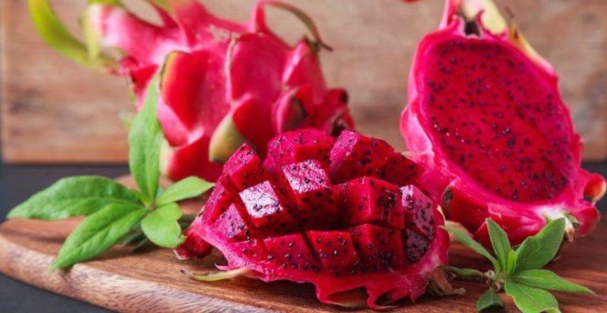

Specification:

* 100 % pure dragon fruit from Indonesian Plantations.
* Variety: *Pitaya Roja*
* Weight: 300 – 800 grams per piece
* Size:
* Super 2 ( 300g – 500g)
* Super 1 (500g – 600g)
* Jumbo ( 700g – 800g)
* Grade AAA ( Export Quality)
* Color: red skin and red flesh
* Maturity: 70% - 90%
* Packing: Vented Plastic Crete or Corrugated Cardboard Box
* Capacity: 5 – 20 kg per packaging
* Load ability:
* 20 feet (10 MT)
* 40 HC ( 20 MT)

**Cocopeat**

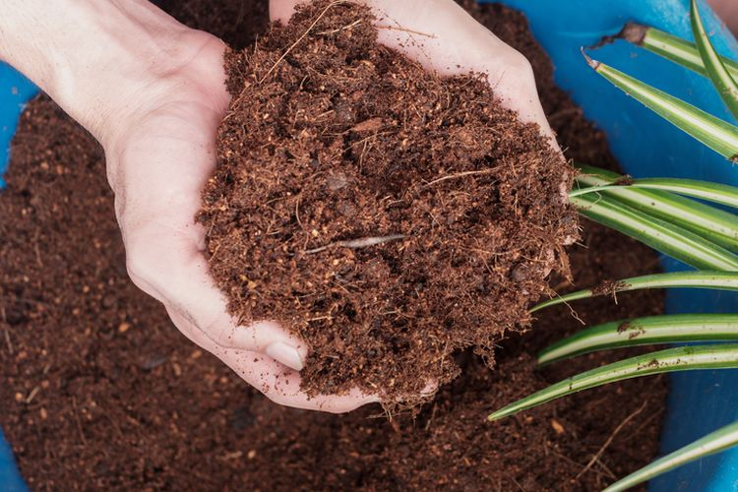

Many benefits can be obtained by using it. Good for use with the ground, or stand alone. Cocopeat is alsowidely chosen as a substitute for soil, cocopeat is easy to absorb and store water. It also has pores, wich facilitate the exchange pf air, and the entry of sunlight. The content of Trichoderma molds, a type of enzyme from fungi, can reduce disease in the soil. Thus, cocopeat can keep the soil loose and fertile.

Micro/macro content:

* Potassium (K)
* Phosphorus (F)
* Calcium (Ca)
* Magnesium (Mg)
* Sodium (Na)

Cocopeat specifications:

* Weight 15 kg/bag
* Electrical conductivity ( EC) = <0.5 ms/cm (affects plant metabolism based on nutrient solution & fertilizer solution)
* Brown
* Water content > 20%

**Cocopeat Blok**

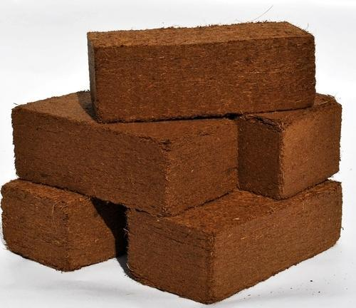

The advantages of cocopeat include being more environmentally friendly. Because it is made of organic material and can be properly degraded in the soil, when it isnot used. Even some types of pests such as those from the ground do not like being in the cocopeat

Specifications of cocopeat (block):

* Size: 30 X 30 X 12 – 15 cm
* Weight: 5 kg
* Brown
* EC: < 0.5ms/cm
* Ph: 5.0 – 7.0
* Moisture: < 25%
* Short fiber content: < 10% (2 mm)
* Contamination control: non – sand, stone, coco shell – fragment
* Drying: sun drying
* Packing: palletized with shrink film
* Certificate: Quality Analysis, Fumigatron, Phytosanitary

High EC specifications:

* Size: 30 X 30 X 12 – 15 cm
* Weight: 5 kg
* EC: < 1.6 ms/cm
* Moisture: < 25%
* Ph: 5.0 – 7.0
* Short fiber content: < 10% (2mm)

**COCONUT FIBER**

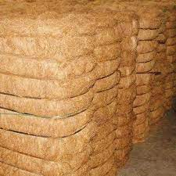

Coconut fiber is fiber from coconut fiber that has been milled or described in the form of long hair and is generally yellow-brown in color. Cocofiber or coconut fiber is the result of processed coconut skin to produce coir fiber that has many benefits.

Specification: (cleaned & pressed):

* Dimension: 115 x 85 x 40
* Weight: 90 x 110 kg / ball
* Moisture: 18 – 20%
* Fiber: 10 cm up

**TESTIMONIAL**

**Mr.Tharusa Srilanka**

Quote: good quality, safe packing until here and fast response, it’s recommended seller

**Mr.Dzika Indonesia**

Quote: fast delivery ,delicious and classy flavor. Thank you seller

**Mr.Amin Pakistan**

Quote: the quality of the coffe is unquestionable.